USB Interface boards V0-3, V0-4 and HSUSB

Dave Roberts
G8KBB

This document describes a hardware module for connecting the N2PK VNA to a USB port of a PC. It describes the construction of a module as an alternative to commercial units. Details on Dave WB6DHW’s HSUSB module is also given.

Four hardware versions exist
- A commercial board
- A design for ExpressPCB
- A generic design
- A similar board by WB6DHW

The ExpressPCB unit was designed to be compatible with the Elrasoft commercial board. This was then updated in a subsequent version for production via any PCB house by means of Gerber files. Dave WB6DHW decided to offer his board, which is a near clone, a kit.

This memo describes all versions.

This is an update of v0-4 and applies to the new drivers from November 2006 – the significant change is to the pinout between interface and VNA – clock and chip select for ADC1 have MOVED!.

In this version WB6DHW’s board is described and the programming details have been updated.

Background

Both of my PCBs are designed to be compatible with the Elrasoft (www.elrasoft.com) board if you do not want to make your own. The main difference is that the versions described here can take a reset chip rather than an RC combination for device reset, as recommended by Cypress. Either the original CY7C68013 or the lower power CY7C68013A may be used.

WB6DHW’s uses the same chip and is almost equivalent to the original designs.

Whether you build or buy, you need to wire it to the VNA and program it with the correct identifiers – see the software guide for details.

ExpressPCB board (layout v0-3)

Each interface board is half of an express PCB miniboard; therefore a run of 3 boards yields 6 modules. The plots below show one board with two modules each.

Generic Gerber files (layout v0-4)

This was a redevelopment of the original ExpressPCB files. It is basically the same but with the following changes

- The position of components has changed slightly
- The board is a couple of millimetres narrower
- The 0603 components have been replaced by 0805 (but the pads will still take 0603)
- One extraneous decoupling capacitor has been removed

The Gerber files include solder mask and silk screen printing

Construction

Construction is simple. There are few parts, mostly surface mount, located on one side of the board.

Note that you may use either the original CY7C68013 or the newer CY7C68013A series parts. The only substantive constructional difference is that the original version requires the use of U3 – the power supply supervisory chip. You cannot reliably use a simple RC network according to Cypress. The A series part claims that you can use an RC network (and proposes 27K/1uF) but the supervisory chip should also work well. Also note that the A series part specified the use of 12pF capacitors for the crystal whereas the original used 18-30pF. Cypress also notes that, whilst they do not guarantee it, 18pF should work well for either.

Attach the resistors and capacitors but you might want to leave the decoupling capacitors near to the USB chip until it has been soldered in for ease of access. The v0-3 board is designed to take the ordinary or the ‘gull wing’ version of C14 but v0-4 accepts only the ordinary version – just bend the pins under if you have gull wing parts. Once assembled, add U2, U4 and (optionally) U3. These are fairly simple to solder as their pin spacing is not as fine as that of U1. Make sure you solder the tab of U4 to the PCB. Now apply power (5V) from a current limited supply and make sure that the regulator is delivering 3.3V correctly. The board without U1 should take just a few milliamps. U1 should now be fitted. An easy way to do this is to carefully position it, solder 2 corner pins, check one last time that it is the right way round and correctly aligned, then run the iron and solder carefully along each side, not worrying about shorting pins too much. Now carefully use desoldering braid to remove all excess solder leaving the pins soldered with very little solder and clear of shorts. Be careful not to drag the braid or iron sideways or you will pull the pins sideways and short them out. It is then hard to correct. The desolder braid will have left lots of flux on the PCB so now clean it thoroughly. Now install X1 and the USB connector J1. If using board version 0-3, when you attach X1 and J1, be careful to ensure that the case of X1 and screening cover of J1 do not short any signal tracks. Finally install J2 if you will be using it, otherwise wires to the VNA connect directly to the pads of where J2 would be. Now apply 5V from a current limited PSU and check for 3.3V from the regulator (note the tab is 3.3V) to make sure there are no power related shorts – the USB port of your PC is unlikely to be current limited. The board should draw under 100 mA (68013) or 30mA (68013A). Finally, plug it in to the PC. Windows should locate it and ask you for the drivers. Do not bother trying to install the software at this point – it is asking for the Cypress development drivers not the VNA drivers – see below. If this happens it is basically working. If you have installed the Cypress development tools, then the drivers from the toolset will load, and the Cypress USB Control panel should detect the board.

WB6DHW’s design

WB6DHW’s uses the same chip and is almost equivalent to the original designs. The connectots differ, two of its components do not meet safety standards and there is an extra RC on the Wakeup line but it should perform fine.

The connectors used differ from the other designs. If you buy Dave’s kit note that most of the connectors are not needed.

There are two components connecting the screen of the USB connector to ground. Ideally these should be mains rated but the components shown by WB6DHW are 50V. These will function just fine but note that they are not adequately rated.

There is an RC time delay on the Wakeup line. This is not used at the moment. As I currently do not use the Wakeup function it does not matter if you fit these or not.

It is important that the power detect pin be connected correctly. There is no 5V or 3.3V output pin on any connector. If you connect the PCB directly to the VNA this does not matter as the best solution is to use the 5V power line of the VNA itself. If however you plan to connect the interface to a DB25 connector, you must connect the VNA Power line via a 10K resistor to a 5V or 3.3V line. In this case you will need to pick up a suitable voltage line from the PCB somewhere – one suggestion is the external power connector as this is not needed in the N2PK – the interface is bus powered.

Connecting to the VNA

The connections to the VNA are defined in the software guide but a copy is shown below. Note that in the event of a discrepancy between this document and the software guide, the software guide takes precedence. Follow the pinout shown by locating each pin on the 10 pin VNA connector and connecting it to the corresponding pin on the USB PCB using the schematic and pinout data. There are two ground wires so connect each to a ground pad. Note that there is one additional signal not present on the 10 pin VNA connector that enables the USB interface to check the presence of the VNA 5V supply. Connect this through a 10K series resistor. This is described in the software manual. If you are using two detectors, connect the second one to port B as described in the software manual. If your VNA uses the ltc2440 and you will be using it in ‘fast’ modes, connect SDI pin as well as shown in the software manual. This requires a small hardware tweak to the VNA PCB if you are using the original Express PCB single detector board – check Paul’s website for details.

Configuration

The final thing you need to do is to configure the EEPROM on the interface so that it corresponds to the identifiers in the software. There are two ways to do this, either use the Cypress development tools or use the N2PK VNA “USB Configure” utility. The latter is the easiest approach and installs the N2PK USB drivers as well.

Configuring by means of the Cypress tools

How to do this is addressed also in the software guide, but in summary you install the Cypress development tools (which are free – www.cypress.com) and use the Cypress USB control panel to write to the EEPROM. This is done by downloading a Cypress supplied utility named “Vend_Ax.hex” and using control panel to instruct that application to write an 8 byte data value to the start of the EEPROM. The observant reader will have noticed that no mention has been made of JP1. This is because it is hopefully never going to be used. If however you make a mess of programming the EEPROM, you will need to disconnect the EEPROM momentarily when the unit is powered up so that it reverts to its cypress default identifiers. This is done by cutting the trace that joins the two pads of JP1 and installing a 2 pin header. Plug the unit in and it should appear as an unprogrammed device. Now install a link on JP1 and reprogram it again. Leave the link in place thereafter (as you have by now cut the trace linking the pins).

Note that since writing, the Cypress tools have changed to a different driver model. Whilst you can use the Cypress tools quite easily, it is recommended that you do not install them but use USBconfigure unless you are certain you understand how to use them.

Configuring by means of “USB Configure” utility

Available from the web is a utility especially designed to configure the USB interface. Basically, it is an automated way to do the tasks described above. When you run it, it allows automatic download of “vend_ax.hex” and comes with predefined configuration strings. It can also form messages to set the VNA but be careful – driving it manually in this way it is easy to lock up the PC comms stack. If this happens it is not damaging – just annoying.

When you run the program, it offers 4 tabs labelled:
- Communicate with adapter
- Download Program
- Program FX2 chip EEPROM
- Setup

Communicate with adapter
This dialog allows you to build messages for the VNA and read the VNA responses. However it will only function when it thinks it is talking to a valid N2PK VNA interface. Exercise caution – if you lock up communications, pull out the lead to the interface and exit the program – that should clear things. To understand the messages, consult the software guide. Note that if you only want to configure the board for use with the N2PK then you do not need to use this dialog at all.

Download program
This is a tool that allows you to send a Cypress FX2 executable program to the chip and start it running. Note that if you only want to configure the board for use with the N2PK then you do not need to use this dialog at all.

Setup
This dialog is used to configure the program. It comes configured with the usual values so if all you want to do is configure the board you do not need to use this dialog other than to make sure that it knows where to find Vend_ax.hex..

Program FX2 chip EEPROM
This is the one to use. Full step by step instructions are shown below.

That’s all there is to it!

Boot notes

The CY7C68013 takes more current than the CY7C68013A. If you do not need the USB 2 high speed mode, you can configure the EEPROM to disable the high speed drivers on power up. This is described in one of the Cypress application notes. If you do do this, you will need to change the device descriptors in the fx2 code as well to indicate USB 1.1 not USB 2.0.

Some comments on the design. The 4.7nF cap and 10Mohm resistor are present because the screen on the USB type B connector is NOT grounded. This is a requirement of USB2.0 specification cabling. However it is not acceptable to let the screen float so these components are included and need to be rated for mains voltage.

R1 / JP1 are not used. In fact, you can omit R1 and JP1. Originally intended to allow recovery from a corrupt EEPROM, this is not a viable recovery method.

Buy or Build?

If you use the Elrasoft unit, its 40 pin connector is wired identically to the one here for compatibility. It is slightly smaller (but I could not easily fit 3 easily on a miniboard so did not bother). It uses the CY7C68013 not the ‘A’ version so ought to have the reset chip U3 but it does not. This contravenes Cypress guidance on resetting the FX2 in bus powered use but seems to work OK. Both PCBs described here (0-3 and 0-4) include U3. Note however that you could fit an RC reset circuit – there are pads visible above and to the right of U2 for this purpose (0-3) and labelled C15 and R5 on v0-4. Their function is obvious – they are not described further. Fit either them or U3 but not both. Note that for the FX2LP (the CY7C68013A) the requirement for U3 is no longer present and the RC reset circuit will work fine according to Cypress current guidance. I believe there may also be a newer version of the Elrasoft with the A series chip now available.

Parts list for V0.3 or 0.4

C1 | 18 - 30pF 0603 (v0-3) or 0805 (v0-4) chip ceramic if using CY7C68013, or 12pF for CY7C68013A (to match X1).
C2 | 18 - 30pF 0603 (v0-3) or 0805 (v0-4) chip ceramic if using CY7C68013, or 12pF for CY7C68013A (to match X1)
C3 | 10uF Case style B 3528 10V surface mount tantalum
C4 | 100nF 0805 X7R chip ceramic
C5 | 10uF Case style B 3528 10V surface mount tantalum
C6 | 100nF 0805 X7R chip ceramic
C7 | 100nF 0805 X7R chip ceramic
C8 | 100nF 0805 X7R chip ceramic
C9 | 100nF 0805 X7R chip ceramic
C10 | 100nF 0805 X7R chip ceramic (omitted on v0-4 board)
C11 | 100nF 0805 X7R chip ceramic
C12 | 100nF 0805 X7R chip ceramic
C13 | 100nF 0805 X7R chip ceramic
C14 | 4n7 250V SM ceramic disk capacitor– Panasonic ECK-TBC472MF. Use only this or equivalent – do not use a low voltage part. The 0-3 PCB will take the normal or the gull wing device (ECK-TBC472MFM). V0-4 is not designed for gull-wing
C15 | With CY7C68013A, fitted only if U3 omitted. 1uF
J1 | USB Type B right angle connector
J2 | 40 pin connector (optional)
JP1 | Not fitted. Used to disconnect EEPROM in case of problems
R1 | 22k 0603 (v0-3) or 0805 (v0-4) chip resistor. Value not critical – just used as a pull-up when reprogramming. Not needed unless EEPROM needs to be disconnected.
R2 | 2k2 0603 (v0-3) or 0805 (v0-4) chip resistor.
R3 | 10M 1206 chip resistor
R4 | 2k2 0603 (v0-3) or 0805 (v0-4) chip resistor
R5 | With CY7C68013A, fitted only if U3 omitted. 27K 0603 (v0-3) or 0805 (v0-4) chip
U1 | CY7C68013-56PVC (the FX2) or CY7C68013A-56PVC (the FX2LP – a low power part)
U2 | 24LC64 SO8 EEPROM (smaller sizes may also be used – see fx2 datasheet. May need tracking change to PCB though). We only use the first 8 bytes of the memory!
U3 | TPS3820-33 SOT23-5 This is a 2.93V supply monitor chip Fit either this or R5/C15 but not both
U4 | LT1117 SOT223 or equivalent 3V3 fixed output LDO regulator. There is quite a price range on different manufacturer’s parts
X1 | 24MHz low profile HC49U (HC49/4H) 18 - 30pF (CY7C68013) or 12 pF (CY7C68013A) parallel resonant

USB Configure
These notes describe how to use the USB configuration utility to program the EEPROM for operation as an N2PK VNA USB interface.

NOTE THAT we here assume that you are using XP. This process has been checked on XPpro and on a clean installation of XPhome.

My thanks to Ian GM3SEK for taking the time to put together the first version of these instructions and to Paul N2PK for pointing out that it would be a useful utility.

STEP BY STEP

Do not connect the VNA to the USB interface until you have successfully completed step 13.

0. Download the USB Configure program from http://g8kbb.roberts-family-home.co.uk together with the latest set of drivers

1. Unzip the driver files into a suitable location. This will install the 'usb configure.exe' program and also create driver subdirectories called 'ezusb' and 'N2PK drivers'. If the latest drivers downloaded are more recent than those from the USBConfigure zip file, replace the drivers with the newer set.

2. Plug in the USB card. Windows will identify there is a new USB device, and may then search for several minutes to find drivers; you have to wait until it gives up. (If you see any messages about "This device will go faster", ignore them and they will go away. See step 10 for more details.)

3. When the "Found New Hardware Wizard" dialog eventually appears:
3.1 Choose "No, do not connect to Windows Update" and click Next.
3.2 Choose "Install from a list or specific location" and click Next.
3.3 Choose "Search for the best driver in these locations", check "Include this location" and Browse to the 'ezusb' subdirectory created in step 1. Click OK and then click Next.

4. The USB drivers are installed. Ignore the "EEPROM missing" error message and click “Next”. It will then tell you that the drivers have not passed Windows Logo testing. Ignore this and click "Continue Anyway" (all this means is that the chip has been found correctly and either the EEPROM is missing or it is blank). When the process completes, click the "Finish" button. You are returned to the Windows desktop and the "Found New hardware" flag pops up at the lower right.

5. Go to the directory you created in step 1 and double-click the 'usb configure.exe' program. If you get a "Compressed Files warning", click "Run". The "N2PK USB Interface Control" dialog opens.

6. Go to the "Setup" tab and use the Browse" button in the "Vend_Ax filename" field to find the 'Vend_Ax .Hex' file in the 'ezusb' subdirectory. Click "Save Settings".

7. Go to the "Program FX2 Chip EEPROM" tab and click "Download".
Watch the messages at the bottom. If the download succeeds, the final line will say "SUCCESS: Program downloaded" and it will enable the "Read" and "Write" buttons on that tab. Click "Read" and you should get 8 bytes of FF. At this point you are communicating correctly with the USB card.

8. In the "Write EEPROM" field of the same tab, select the "N2PK" option from the drop-down list and click "Write Data". That should result in a success message, and the EEPROM will have been programmed. Now click the "Read" button and check that it reads back the same string that was programmed in (see "Data to be written" at bottom of tab).

If the EEPROM does not read back correctly, go to the drop-down list, select the "Erase (write FFs)" option and repeat the "Write Data" operation to (try to) reset the EEPROM. Do not pull the USB plug out while the EEPROM is not reading back correctly, or you will lose control of the EEPROM. If this happens you will need to follow the instructions in the hardware documentation for the interface but in précis, you will need to cut the link between the EEPROM data and FX2 I2C data lines and install a jumper. When the device is then booted up it will again appear to have no EEPROM. Whilst in this state the link can be remade and the EPROM erased and reprogrammed.

When all is OK in step 8, close the 'usb configure.exe' ("N2PK USB Interface Control") program.

9. Pull the USB plug out and reconnect it. When the "Found New Hardware Wizard" appears:
9.1 Choose "No, do not connect to Windows Update" and click Next.
9.2 Choose "Install from a list or specific location" and click Next.
9.3 Choose "Search for the best driver in these locations", check "Include this location" and Browse to the 'N2PK drivers' subdirectory created in step 1. Click OK and then click Next.
If the wizard does not appear, open Control Panel, select the “System” Icon and from there select the “Hardware” tab. Then click the “Device Manager” button. Select the first item in the list and from the Action menu select “scan for hardware changes”. This should then cause Windows to find the device.

10. The N2PK drivers are installed. Ignore the "Has not passed Windows Logo Testing" message and click "Continue Anyway". When the process completes, click the "Finish" button. You are returned to the Windows desktop and the "Found New hardware" box pops up.

If the "Found New Hardware Wizard" appears again, repeat steps 9 and 10 until Windows can routinely find the USB interface when it is plugged in.

Note: from now on, whenever you plug the USB interface into a USB1 port (as used in older PCs), you may see an irritating message that "This device can perform faster". Ignore it.

Note 2: If the PC wants to reboot let it. The driver will in fact be working correctly but it is simpler to get it over with. You may also find that if you plug it in to a different USB port it will reinstall the drivers again. This should only happen once per port though.

11. Re-run the 'usb configure.exe' program (see step 5). At the "Compressed Files warning", click "Run". The "N2PK USB Interface Control" dialog opens.

12. Go to the "Communicate with Adapter" tab and click "Check VNA interface". You should get an "N2PK VNA Interface found" message, and the "Read VNA Interface" and "Write VNA Interface" buttons will be enabled.

13. Click "Read VNA Interface" - still with no VNA connected - and you
should read the message '00 00 X0 C0 00', where X is 8 or 4.

Now close the program, unplug the interface card and proceed to connect the interface to the N2PK VNA. Follow the instructions in Win4VNA as to how to enable the use of the USB interface with the application.

PROGRAM NOTES

Note that if you wish you can also send commands to the USB chip from the configuration utility but beware – it is easy to block the communications if you are not careful. If this happens just pull the USB cable out, close the application and plug it in again.

The interface also allows you to download programs to the USB chip directory for test purposes. This is useful for testing variants of the FX2 chip application but note that if the USB cable is pulled out and reconnected the chip will revert to the current N2PK VNA firmware.

Also one other point. In playing with the interface it is possible that (for example after programming the EEPROM and disconnecting/reconnecting the chip it will be allocated a different driver name (for example ezusb-1 instead of ezusb-0) You can find out if this has happened and change the name from the setup screen.

PROGRAM DETAILS

When the program starts it opens at the “communicate” screen. This is used to send messages to and read messages from the VNA. This means however that the VNA interface program must be running on the FX2 chip before this can be done. Therefore either the EEPROM must have been programmed and the driver automatically downloaded, or the download process has been used to put the program onto the chip. In either case, reading the interface string descriptor 2 will yield a string that we can recognize. Specifically the string we look for is set on the “setup” screen under the name “Configuration string for N2PK VNA”. If we find this, then the read and write buttons are enabled. When ‘read’ is then clicked, a message is read from the interface (see the N2PK USB firmware guide for details). When Write is clicked, whatever is in the Write area is sent to the chip. Any message may be entered here as hex, or the Set and Raw buttons may be used to create a message. Again, see the firmware guide for details.

One thing to note. It is dead easy to send a message that will pause communications, and I am not certain that there is not a bug here somewhere so if it locks up, disconnect the interface momentarily.

The second screen is “Download Program”. This allows any program (any VALID program) to be sent to the FX2 chip. Just browse for a file (only FX2 HEX files are supported) and click on download. The idea is that this screen would normally be used to send new FX2 executables to the chip whilst testing new firmware.

The third screen is the “Program FX2 chip EEPROM” screen. It is pretty well described above. Format Data button is a null function, it just tries to get you to think about any non standard value that you are going to write.

Final screen is “Setup”. These are the 3 basic configuration items that may be changed by the user. The most likely to be changed are the driver name and the location of Vend_Ax.hex. When a device is plugged in, the ezusb.sys driver allocates it a driver name. These are usually “ezusb-“ followed by a digit 0..9. Typically you will only ever see ezusb-0 but there is one situation that can cause confusion. When you reprogram the EEPROM then unplug the device and plug it in again, ezusb.sys may allocate it “-1” thinking that “-0” is still connected. You can search for devices using the “find devices” button.

Vend_ax is used to program the EEPROM. It is an FX2 program that will accept requests to program the EEPROM and must be running in the FX2 before you can try to program the EEPROM. The setup program allows the location of this file to be set.

The final item is the string that needs to be present in configuration string 2 of the FX2 in order for us to be assured that the USB interface program is running on the FX2.

When “store” is clicked, the current settings are stored in the registry and reloaded next time the program runs.

Loading the drivers

OK, the drivers is not the most interesting thing on the planet – BUT PLEASE READ THIS BIT !!!!
To load the drivers you browse to the drivers files (the bit with files like “ezusb.sys and n2pkvld.sys” in it when prompted.

If you want to update the drivers though a bit of care is needed. Here are the instructions. After you have done this UNPLUG THE USB INTERFACE, POWER DOWN THE PC AND POWER IT UP AGAIN. If you simply hibernate the PC the drivers and USB interface will hibernate too and they drivers will not be updated on the chip. This can get very confusing otherwise. Anyway, here are the steps to follow:
- save the new drivers somewhere and unzip them
- with the interface plugged in, go to control panel \ system \ hardware \ device manager
- open up 'usb controllers' and find the N2PK interface
- double click to get properties
- select driver / update driver
- select "install from a specific location (advanced)" and Next
- tick 'include this location in search and browse to the files you unzipped. click next
- it should offer you one or more drivers that include the relevant version number such as “0.1.17.0”. Scroll right and select the most recent one with the name " n2pkvna.inf"
- click next. It will tell you it is not signed - click continue anyway then let it finish

NOW POWER DOWN UNPLUG AND POWER UP AGAIN !

Updating the drivers

If you have previously installed the drivers and wish to update them proceed as above but if it fails, proceed as below. Note this is a ‘belt and braces’ method – the simplest way is to follow the install instructions above but with the new drivers. However some people found that it does not always install correctly. If this is the case then proceed as below.

- save the new drivers somewhere and unzip them
- with the interface plugged in, go to control panel \ system \ hardware \ device manager
- open up 'usb controllers' and find the N2PK interface
- right click and select ‘uninstall’. Follow instructions to uninstall driver. Leave the device manager window open – you will use it again later.
- unplug interface
- browse to directory c:\windows\system32\drivers. There should be a file there labelled “n2pkvld.sys”. Delete it.
- Plug the interface in.
- Go to the device manager screen. Check that there is now an unknown device in the USB Controllers section called “Using N2PKvna.inf for EZ-Loader before ReNumeration (n2pkvld.sys)". If not, and there is a device called “Cypress N2PK VNA USB Interface (ezusb.sys)” then n2pkvld.sys was not deleted – unplug the interface, search for all copies other than the one you extracted in step 1 and delete them. No go back to step 7
- right click on the device “Using N2PKvna.inf for EZ-Loader before ReNumeration (n2pkvld.sys)" and select “update driver”
- select "install from a list or specific location (advanced)" and click ‘Next’
- tick 'include this location in search’ box and browse to the files you unzipped. click next
- If it should offer you one or more drivers that include the relevant version number such as “0.1.17.0”. Scroll right and select the most recent one with the name "n2pkvna.inf"
- click next. It will tell you it is not signed - click continue anyway then let it finish. If it repeats the process let it happen again.

Now check that the installed version is as expected. From device manager you should now see a device “Cypress N2PK VNA USB Interface (ezusb.sys)”. Double click it and select ‘driver’ box – the driver version should be as per the version you installed. On ‘details’ tab select the item ‘Hardware IDs’ from the drop down list. There should be a line like “USB\Vid_0547&Pid_1005&Rev_00xx’ where ‘xx’ is the same two digits as the third number in the driver version number ‘0.1.xx.0’

Unplug the interface, plug it in again and recheck the versions.

USB / VNA connections

From the software guide the port usage is this. Note that this represents a significant change from previous firmware. ADC1 control has been moved to port B, there is now a single ADC clock line as per Paul’s design and the two other port A lines are software controllable switch lines. The signal names of the ADC clock and CS lines have been altered slightly to align with Paul’s documentation. The bit definitions apply to all versions, 0.3, 0.4, Elrasoft and HSUSB but HSUSB connectors differ to the other three.

// bit definitions for IO ports
//
// PortA main VNA I/O
//
#define bmADC1SdoPin bmBIT7 // Input bit
#define bmLoDdsDataPin bmBIT6
#define bmRfDdsDataPin bmBIT5 // rf data shares pin with…
#define bmAdcSdiPin bmBIT5 // …adc serial data in
#define bmResetDdsPin bmBIT4
#define bmWClkDdsPin bmBIT3
#define bmFQUDDdsPin bmBIT2
#define bmSwitch1Pin bmBIT1 // used to be ADC1 CS – moved to port B bit 5
#define bmSwitch0Pin bmBIT0 // used to be ADC1 SCLK – moved to port B bit 0

//
// PortB second VNA I/O port
//
#define bmADC2SdoPin bmBIT7 // Input bit
#define bmVNAPower bmBIT6 // Input bit
#define bmADC1CsPin bmBIT5 // previously unused
#define bmAtten2 bmBIT4
#define bmAtten1 bmBIT3
#define bmAtten0 bmBIT2
#define bmADC2CsPin bmBIT1
#define bmADCnSClkPin bmBIT0 // now common clock for both ADCs

From the schematic and the above we get this. Note that whilst you can connect to the 25 pin D connector, the pinouts of the USB interface are ordered to connect in sequence to the 10 pin connector of the VNA itself (and you should keep the leads short anyway!). If you want to use the DB25 and you use the second ADC note that the second ADC clock needs separate connection.

USB FX2 Chip Description VNA Connector Connector
pin pin Function VNA (10 pin) DB25
=================================================================================================
1 - Ground Ground 3, 3# 18 - 25
2 - +3.3V OUTPUT unused
3 SDA I2C Data Line unused
4 SCL I2C Clock Line unused
5 IFCLK Interface Clock unused
6 CTL0 CTL0 unused
7 CTL1 CTL1 unused
8 CTL2 CTL2 unused
9 PA0 PortA Bit0 Switch 0 - 1
10 PA1 PortA Bit1 Switch 1
11 PA2 PortA Bit2 DDS FQ_UD 4 5
12 PA3 PortA Bit3 DDS CLK 5 4
13 PA4 PortA Bit4 Reset DDS 6 6
14 PA5 PortA Bit5 RF DDS DATA & ADC SDI 8, 8# 2
15 PA6 PortA Bit6 LO DDS DATA 9 3
16 PA7 PortA Bit7 ADC1 SDO 10 11
17 RESET RESET OUTPUT unused
18 WAKEUP Chip Wakeup unused
19 - Ground Ground 7, 7# 18 - 25
20 PB0 PortB Bit0 ADC2 SCLK 1, 1# 7
21 PB1 PortB Bit1 ADC2 CS 2# 9 *see below
22 PB2 PortB Bit2 Attenuator bit 0 14 *see below
23 PB3 PortB Bit3 Attenuator bit 1 16 *see below
24 PB4 PortB Bit4 Attenuator bit 2 17 *see below
25 PB5 PortB Bit5 ADC1 CS 2 8
26 PB6 PortB Bit6 VNA Power detect * see below(power detect)
27 PB7 PortB Bit7 ADC2 SDO 10# 12 *see below
28 PD0 PortD Bit0 unused
29 PD1 PortD Bit1 unused
30 PD2 PortD Bit2 unused
31 PD3 PortD Bit3 unused
32 PD4 PortD Bit4 unused
33 PD5 PortD Bit5 unused
34 PD6 PortD Bit6 unused
35 PD7 PortD Bit7 unused
36 CLKOUT CPU clock out unused
37 RDY0 RDY0 unused
38 RDY1 RDY1 unused
39 - Ground Ground 18 - 25
40 - +5V OUTPUT unused

NOTE THAT

- The interface supports two ADCs, either, both or neither of which may be the 2440 or 2410. If the 2440 is used, then the SDI pin(s) may either be tied high or low or (preferably) connected to PortA Bit 5. This allows the CPU to program the conversion rate of any 2440 connected. Note that for this purpose the RF DDS DATA pin serves a dual purpose.

- Pins with ‘#’ against them are the corresponding pins on a second 10 pin N2PK connector for the second detector. Don’t forget the ground pins as well though!

- Note that the ADC chip select and data pins are separate for BOTH ADCs but the CLK is now common between both ADCs to make interconnection with a parallel port wired to Paul’s standards easier.

- Note that portB bit 6 is used to detect the 5V from the VNA. DO NOT CONNECT THIS DIRECTLY TO 5V- connect a 10k resistor in series between the pin and power.

- Port D is unused.

- The USB FIFO interface handshake pins (CTLx & RDYx) are unused.

- The clock outputs are unused (and the software switches off the main clock output to reduce noise)

PINS MARKED "*SEE BELOW":

- Apart from the ADC power detect function, these pins are used only for the second ADC & extended functions in Paul's documentation and are provisional (as Paul may change them yet).

Connections for WB6DHW’s board

J160 | DB25 | PORT | FUNCTION | H2 | H3
1 | 7 | PB0 | DET1 2 SCK |  | 2
2 | 8 | PB5 | DET1 Ncs |  | 12
3 | G,22
4 | 5 | PA2 | DDS FQ_UD | 11
5 | 4 | PA3 | DDS W_CLK | 9
6 | 6 | PA4 | DDS RESET | 7
7 | G,23
8 | 2 | PA5 | RF DDS DATA, DET1 2 SDI | 5
9 | 3 | PA6 | LO DDS DATA | 3
10 | 11 | PA7 | DET1 nSDO | 1
J360
1 | 7 | PB0 | DET1 2 SCK |  | 2
2 | 9 | PB1 | DET2 nCS |  | 4
3 | G,19
4 | X
5 | X
6 | X
7 | G,20
8 | 2 | PA5 | RF DDS DATA, DET1 2 SDI | 5
9 | X
10 | 12 | PB7 | DET2 nSDO |  | 16
 | 1 | PA0 | TEST SET SW | 15
 | 14 | PB2 | ATTEN0 |  | 6
 | 16 | PB3 | ATTEN1 |  | 8
 | 17 | PB4 | ATTEN2 |  | 10
+5 thru 10K ohms |  | PB6 | VNA PWR |  | 14

Note that ideally PB6 is connected via 10K resistor to the 5V output of the VNA. If you cannot do this then connect it to 5V locally on the PCB.

Note also that the WB6DHW board puts an RC combination on the Wakeup pin of the chip. I cannot guarantee that I won’t use this pin in the future for another purpose so note that ideally you should not populate these components, but if you have already assembled them do not bother to remove them. Their presence and the difference to the original board is not an error and not a possible reason for having difficulties in getting the interface to work.

Finally note also that the voltage rating of the R and C connecting screen and ground on the USB connector are not adequately rated for safety but again the difference here does not represent a reason for having problems with the board.

Hardware V0-3 (Express PCB)
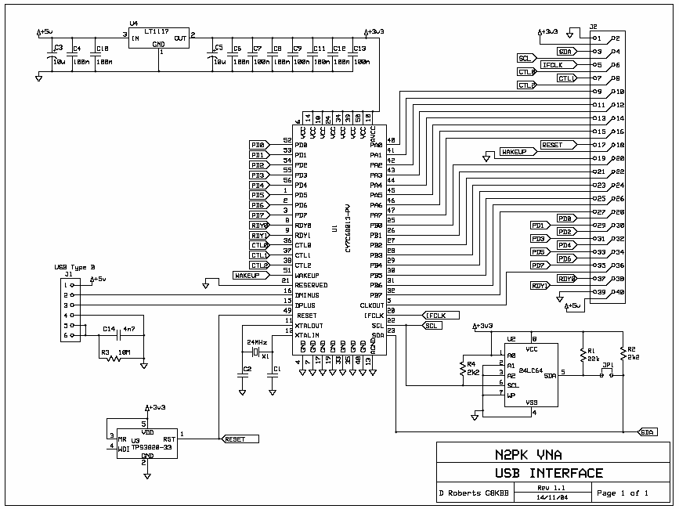
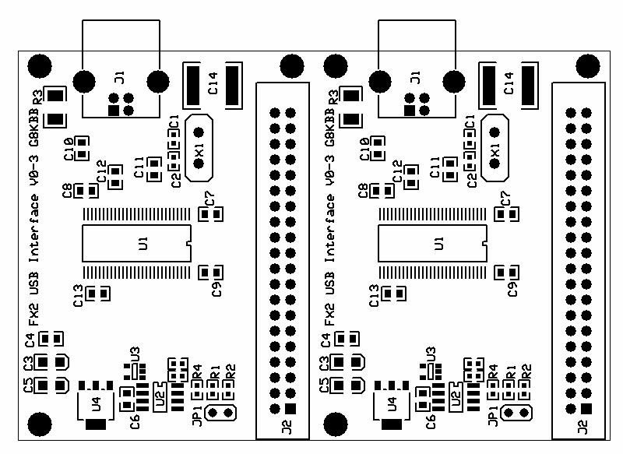
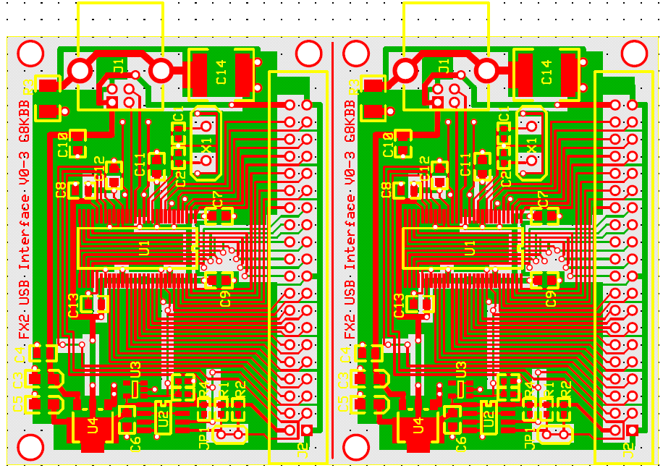
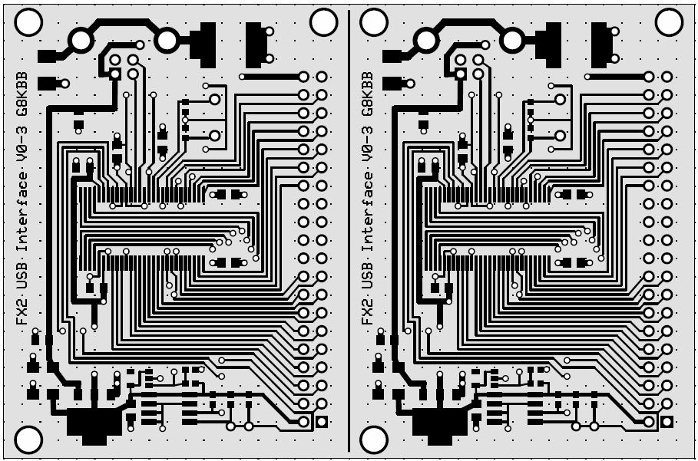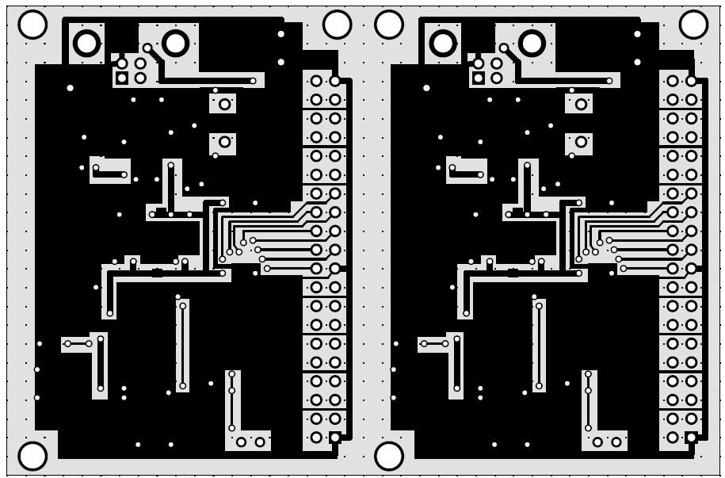
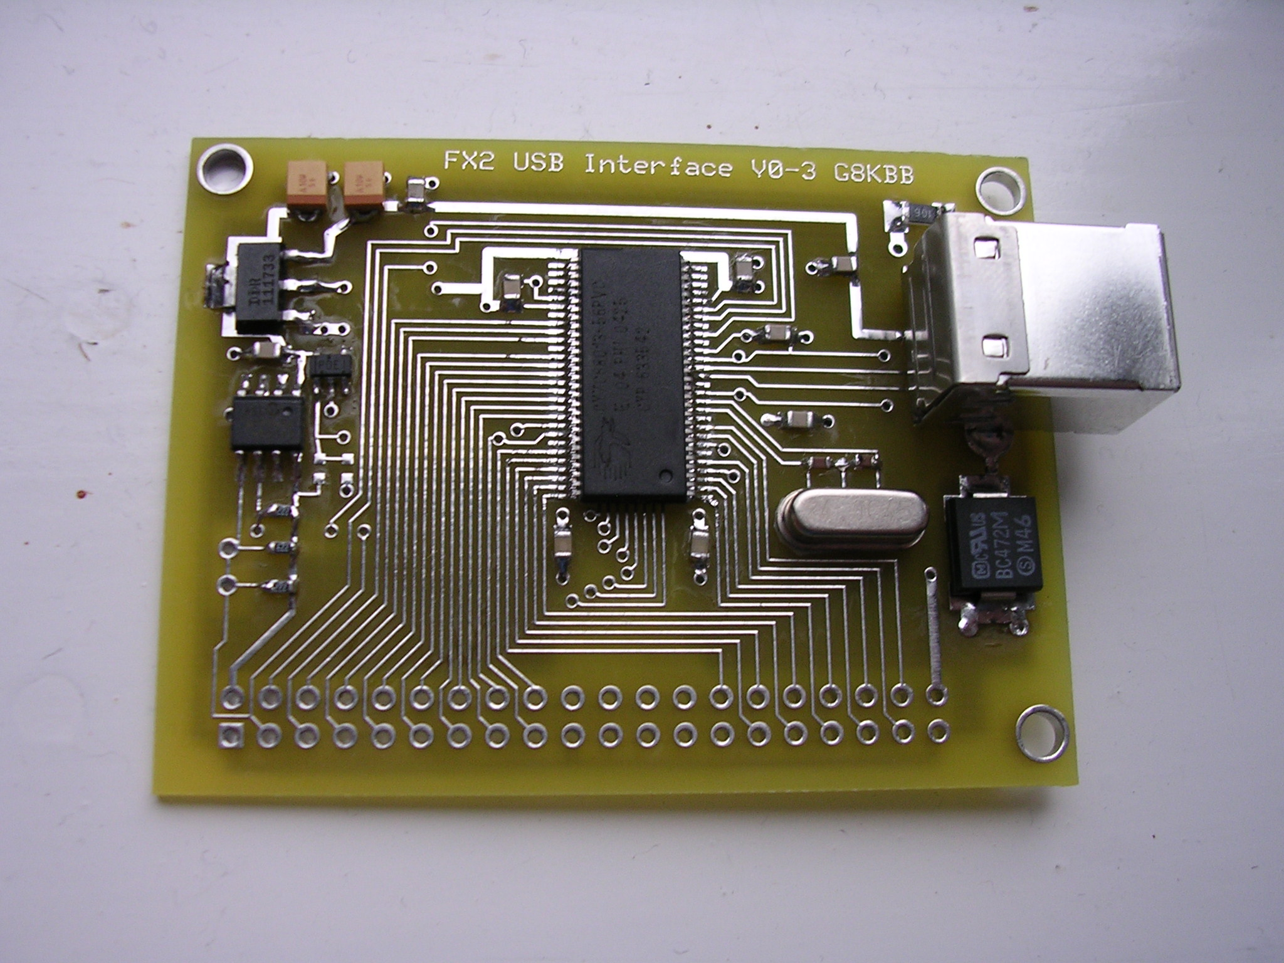

Hardware V0-4 (Generic)
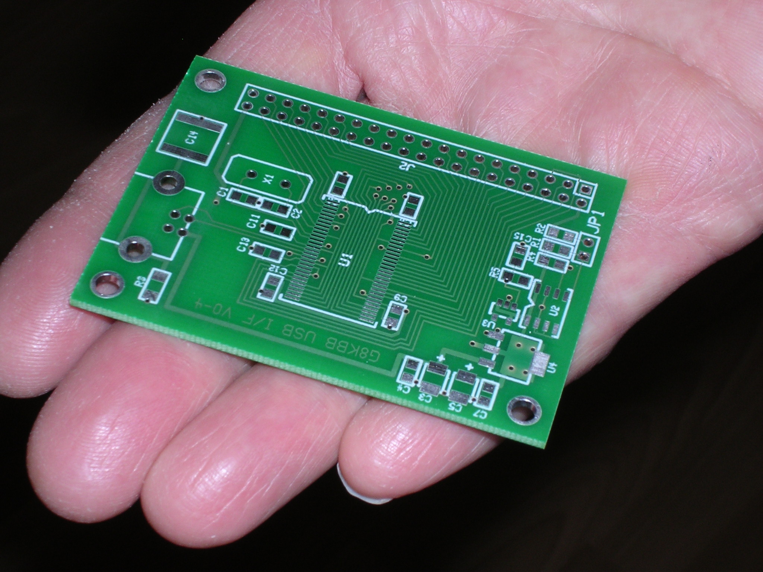
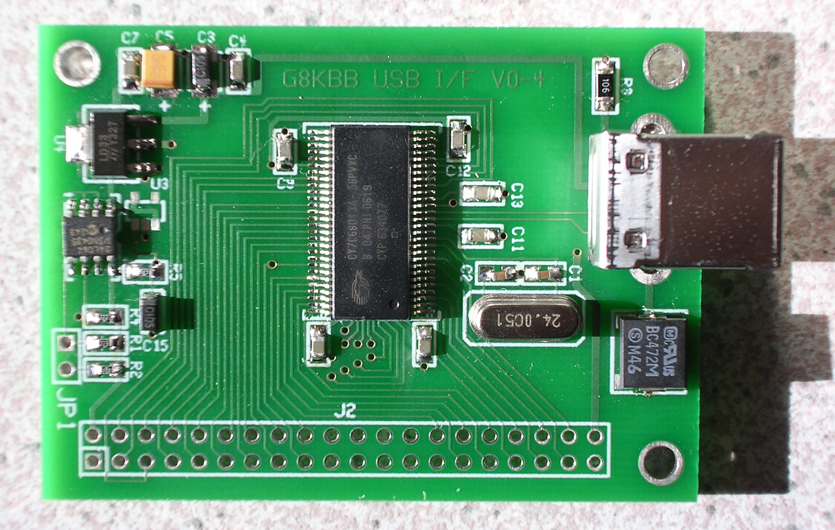

*** End of Document ***

